MICA TAPE SERIES
Phlogophite,  TYPE- CP25G  Temp rating: 750 °C to 800 °C  Std used - IEC 60331-1/2/3/21 | 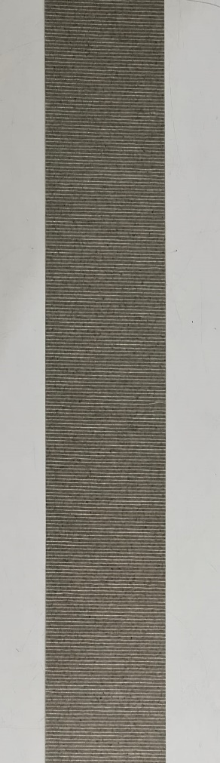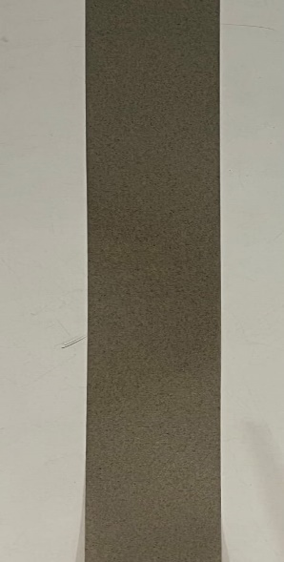 | Phlogophite + Inorganic, TYPE- CP25GE  Temp rating: 750 °C to 950 °C  Std used -BS 6387 CWZ, IEC 60331-  1/2/3/21, BS EN 50200 | 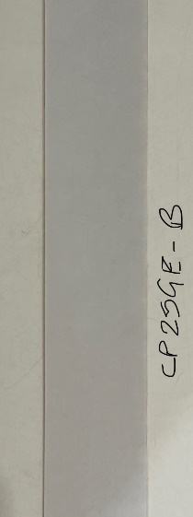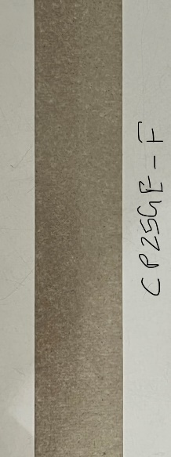
Muscovite,  TYPE-CM25G  Temp rating: 950 °C  Std used -BS 6387 CWZ | 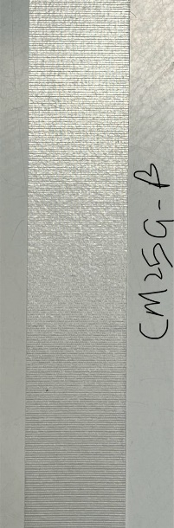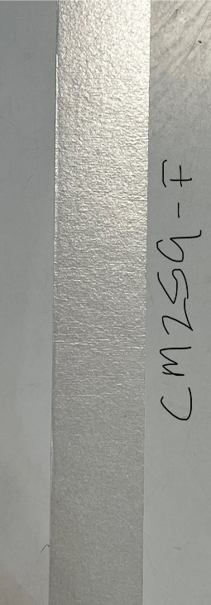 | Muscovite + Inorganic, TYPE-CCM25GE  Temp rating: 950 °C to 1200°C  Std used -BS 7846, BS EN 50200, BS 8434-2 | 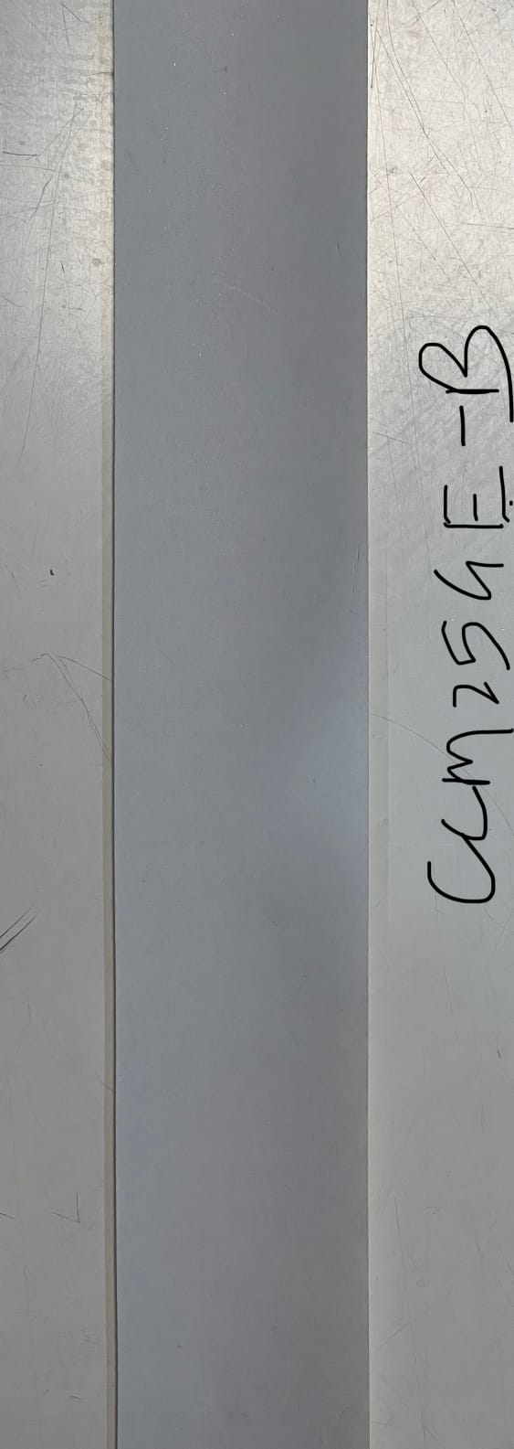
Glass + Muscovite + Glass,  TYPE-CM25DG  Temp rating: 950°C  Std used -BS 6387 CWZ | 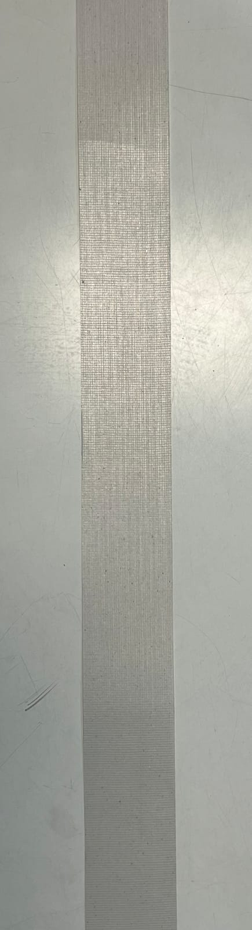 | Muscovite Calcined  TYPE-CCM25G  Temp rating: 950°C  Std used -BS 6387 CWZ, BS EN 50200 | 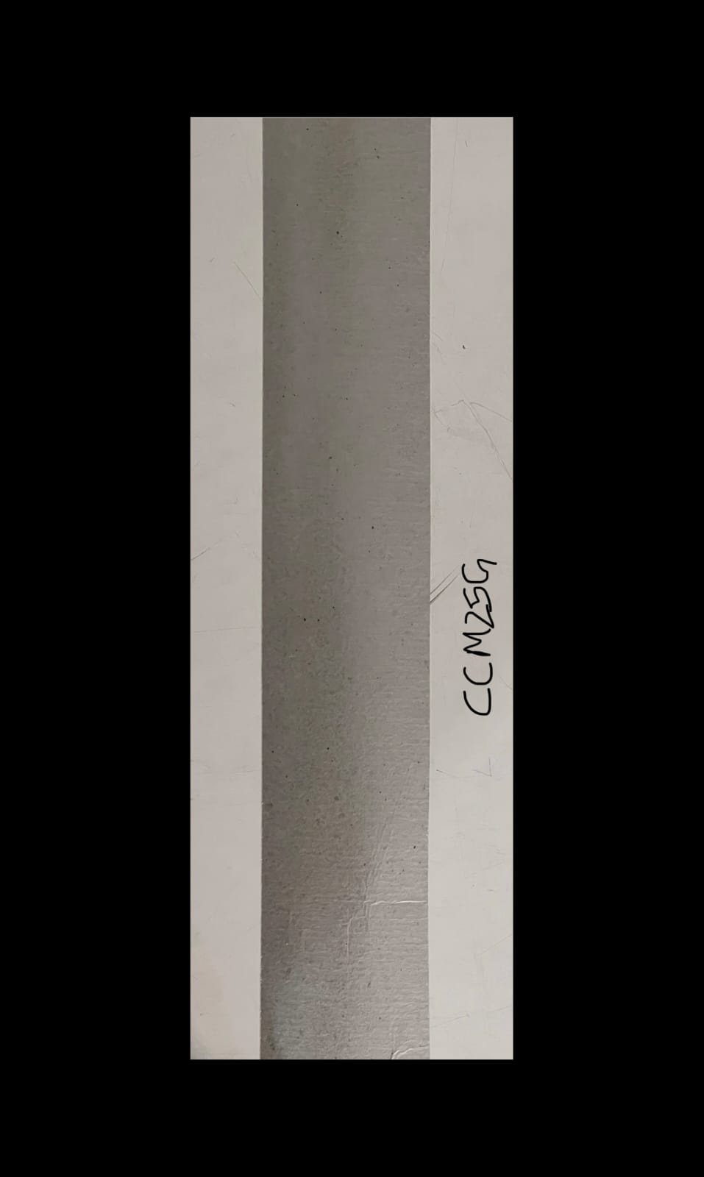

Mica Taping on Conductor

Chhaperia tapping Facility, The Fully automatic Mica Tapping facility in the industry at Chhaperia . Our mica-taped conductors utilize premium mica tape to deliver exceptional insulation properties, particularly in high-temperature environments. Experience enhanced conductor reliability with our mica taping services. Our mica taping process creates a robust insulation barrier around conductors.

Chhaperia Tapping Feature

- Conductor Supplied by the Customer.
- Tapping service as per customer specification.
- Inhouse Facility of Fire Testing Lab.

Chhaperia Mica Tape which can meet various Standard as below: -

Type Suitable for
CP25G IEC 60331-1/2/3/21
CM25G BS 6387 (C W & Z)
CP25GE BS 6387 (C W & Z), BS EN 50200,
CCM25GE BS 6387 (C W & Z), BS 7846 (CATEGORY F2, F120) & BS 8434-2
(CAT- ph120 & Annex E)

Tapping Ranges of Conductor: - 0.5 SQMM to 20 SQMM.

Overlapping %: - 10 to 50% Coverage %: - 100 No of Layer: - 1 to 3

Water Blocking Tape Series

Non-Conductive

Type- CHSNW 15  T- 0.2mm  T.S – 25 to 30N/cm  GSM- 55 E- 11%  S/S- 5 S/H- 8 | 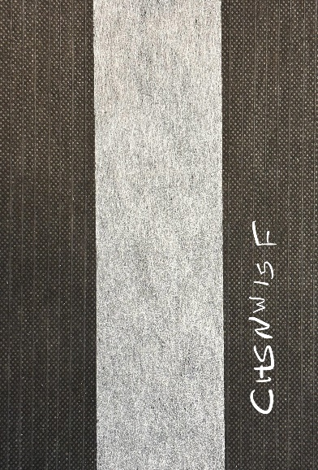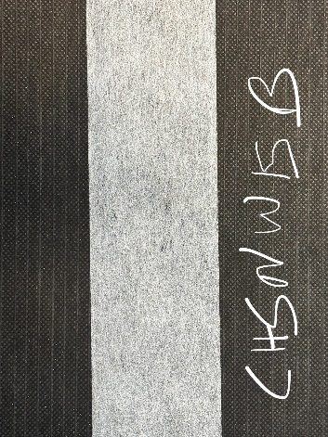 | Type- CHDNW 20  T- 0.2mm  T.S – 25 to 30N/cm  GSM – 80 E – 11 %  S/S – 10 S/H – 15 | 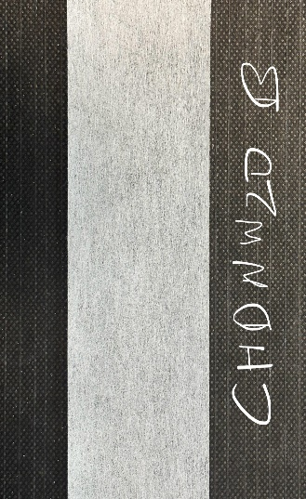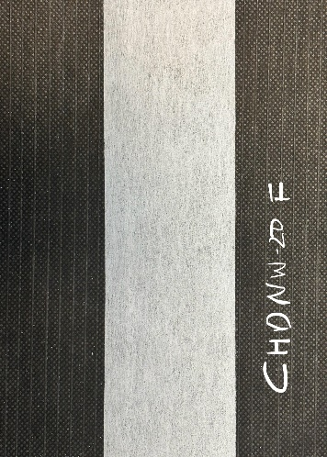
Type- CHDNW 25  T – 0.25mm  T.S- 35N/cm  GSM- 90 E- 11%  S/S- 10 S/H- 14 | 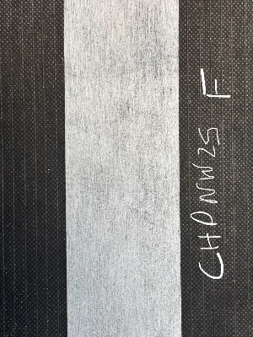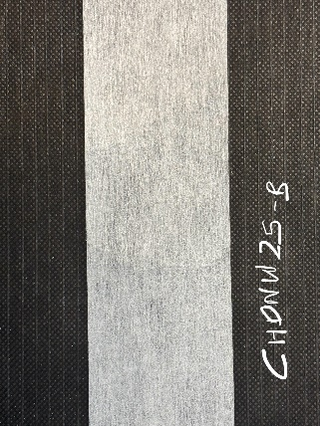 | Type- CHDNW 30  T- 0.30mm  T.S – 35 N/cm  GSM – 100 E – 11 %  S/S – 10 S/H – 12 | 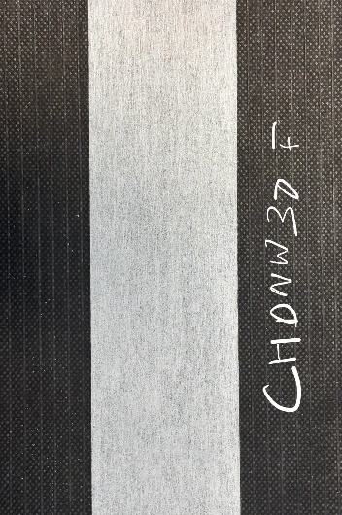
Type- CHDNW-R1225  T – 0.25mm  T.S- 80 N/cm  GSM- 100 E- 17%  S/S- 10 S/H- 14 |  | Type- CHDNW-30R  T- 0.28mm  T.S – 100 N/cm  GSM – 100 E – 15 %  S/S – 10 S/H – 15
Type- CHDNW-28CAB  T – 0.28mm  T.S- 30 N/cm  GSM- 60 E- 13%  S/S- 8 S/H- 9 | 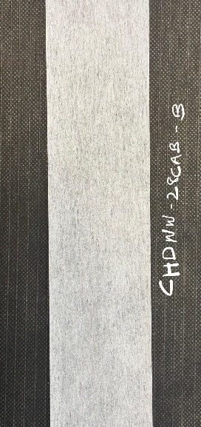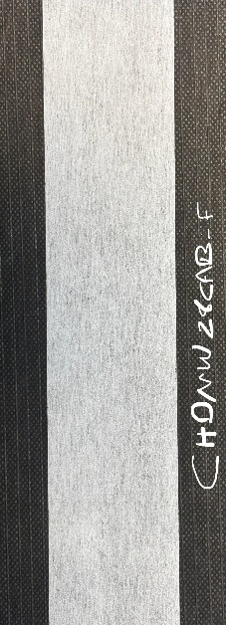
Water Blocking Tape Series

Semi-Conductive

Type- CHDSW 25  T – 0.25mm  T.S- 35N/cm  GSM- 100 E- 12%  S/S- 10 S/H- 15 S/R ≤ 1500 Ω | 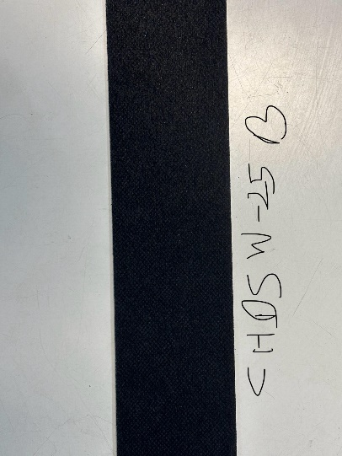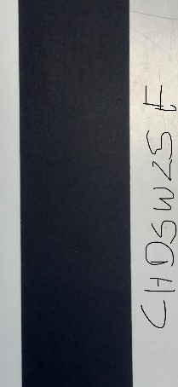 | Type- CHDSW 30  T- 0.3mm  T.S – 40N/cm  GSM – 110 E – 12 %  S/S – 8 S/H – 12  S/R - ≤1500 Ω | 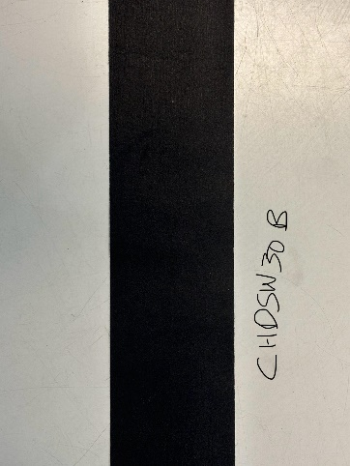
Type- CHDSW 35  T – 0.35mm  T.S- 40N/cm  GSM- 135 E- 12%  S/S- 12 S/H- 15  S/R - ≤1500 Ω |  | Type- CHDSW 4189CAB  T- 0.40mm  T.S – 45 N/cm  GSM – 100 E – 12 %  S/S – 6 S/H – 8  S/R - ≤1500 Ω | 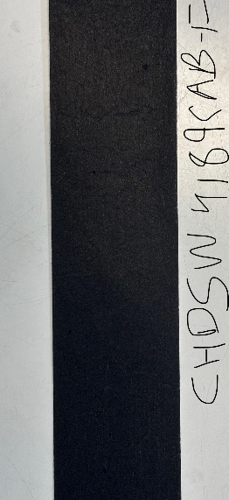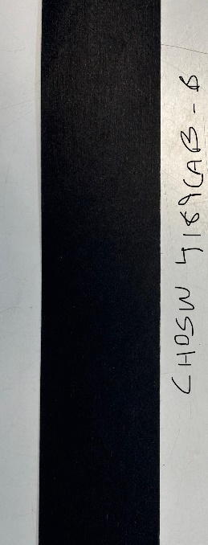
Type- CHDSW41CAB  T – 0.40mm  T.S- 50 N/cm  GSM- 110 E- 12%  S/S- 8 S/H- 10  S/R - ≤1500Ω |  | Type-CHDSW40R  T- 0.40mm  T.S – 80 N/cm  GSM – 160 E – 14 %  S/S – 12 S/H – 16  S/R - ≤1500 Ω | 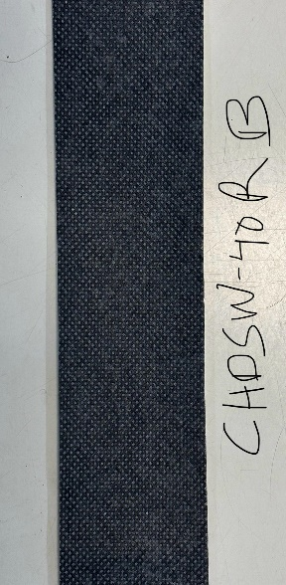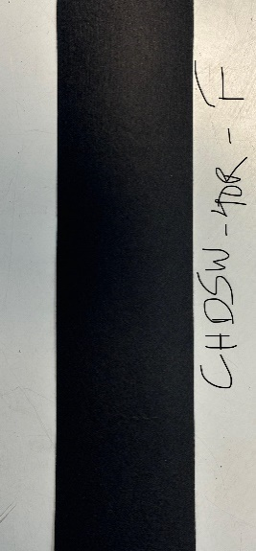

Semi-Conductive Woven Tape

Type- CHSCWWBT 15  T – 0.15mm  T.S- 120N/cm  GSM- 130 E- 20%  S/S- 4 S/H- 6  S/R - ≤2000 Ω |  | Type- CHSCWWBT 22  T- 0.22mm  T.S – 180N/cm  GSM – 180 E – 20 %  S/S – 5 S/H – 3  S/R - ≤2000 Ω
Copper wire woven Semi-Conductive WBT Tape

Type- CHCWSCWBT 35  T – 0.35mm  T.S- 500 N/Width  GSM- E- 5 %  S/S- 3 S/H- 5  S/R - ≤1500 Ω | 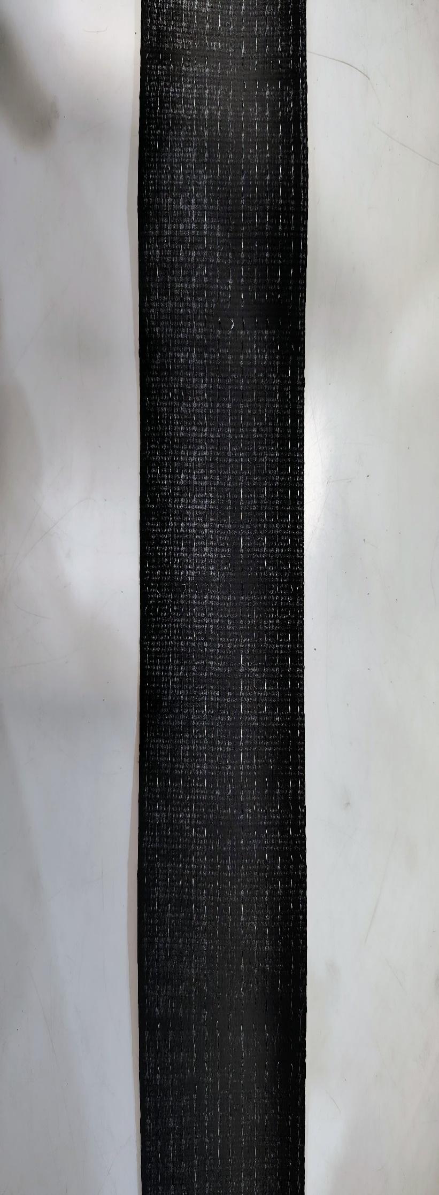 | Type- CHCWSCWBT 45  T- 0.45mm  T.S – 500N/Width  GSM - E – 20 %  S/S – 5 S/H – 3  S/R - ≤2000 Ω | 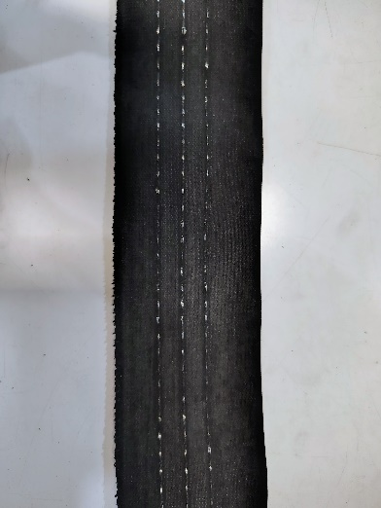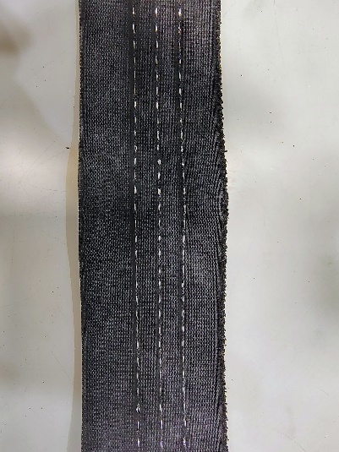

Semi Conductive Non-Woven Tape

Type- CHCNW-12  T – 0.12mm  T.S- ≥18 N/cm  GSM- 45 E- 10 %  S/R - ≤2000 Ω | 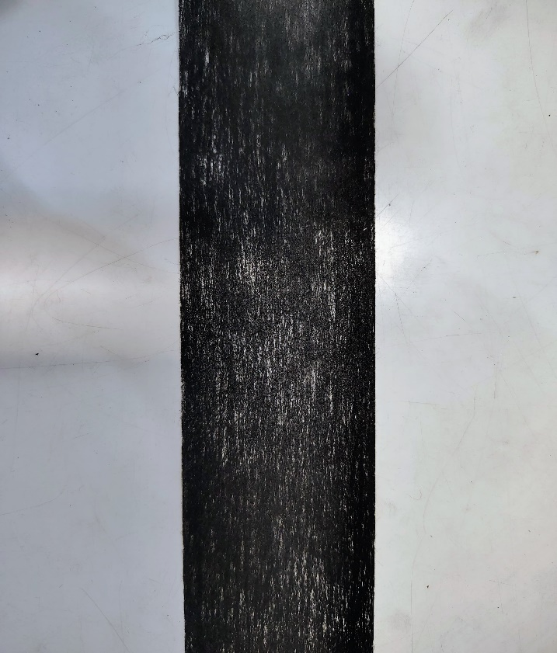 | Type- CHCNW-20  T- 0.2mm  T.S – ≥35N/cm  GSM - 60 E – 12 %  S/R - ≤2000 Ω | 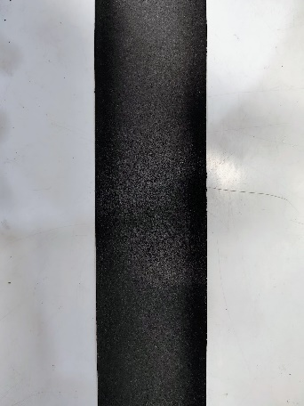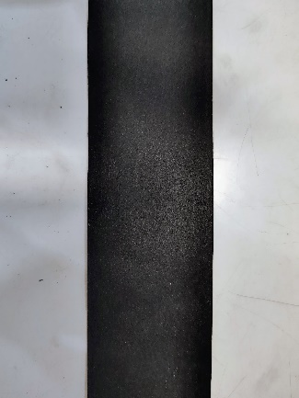

Semi Conductive Woven Tape
Type- CHN 20 R  T – 0.20mm  T.S- ≥200 N/cm  GSM- 170 E- 25 %  S/R - ≤1000 Ω | 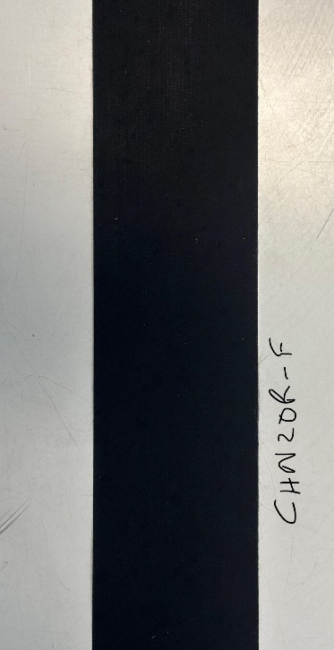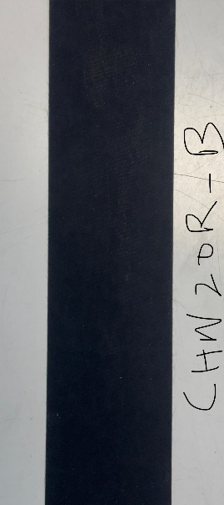 | Type- CHN 12 R  T- 0.12mm  T.S – ≥120  GSM - 100 E – 20 %  S/R - ≤1500 Ω | 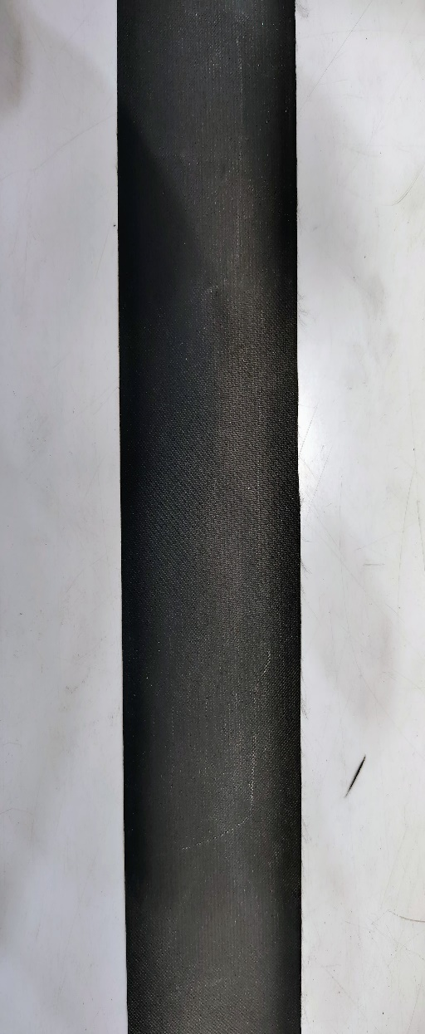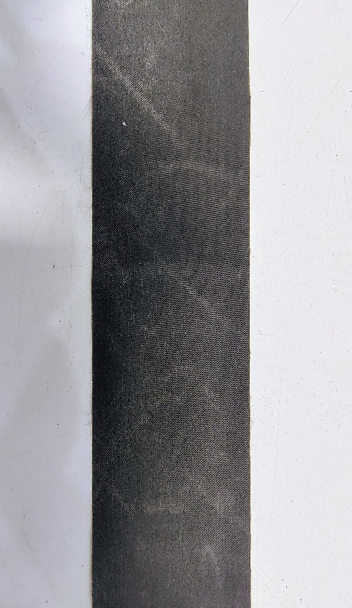
Type- CHN 20 HT  T – 0.20mm  T.S- ≥300 N/cm  GSM- 170 E- 25 %  S/R - ≤1500 Ω |  | Type- CHN 12 S  T- 0.12mm  T.S – ≥120  GSM - 100 E – 20 %  S/R - ≤2000 Ω

Semi Conductive Water Blocking Foam Tape

Type- CHSMWBT-F-100  T – 1.0mm  T.S- ≥35 N/cm  GSM- 270 E- 12 %  S/R - ≤1500 Ω |  | Type- CHCNW-125  T- 1.25mm  T.S – ≥40N/cm  GSM - 300 E – 12 %  S/R - ≤1500 Ω | 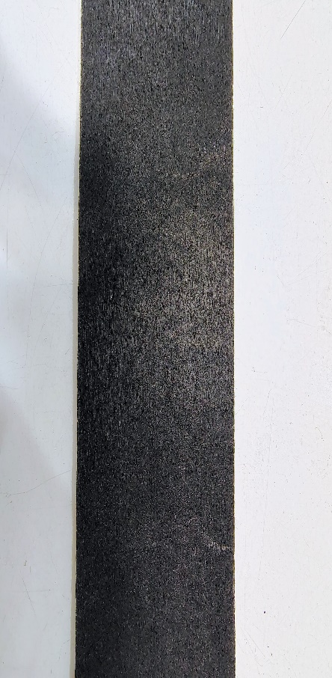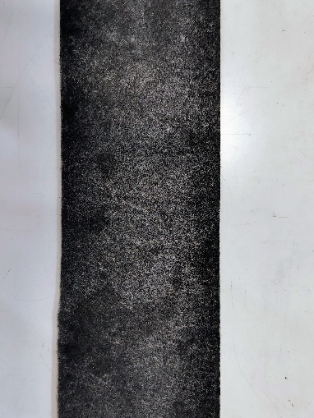
Type- CHSMWBT-F-150
T – 1.5mm
T.S- ≥40 N/cm
GSM- 350 E- 12 %
S/R - ≤1500 Ω

Other Tapes

NAME-LSZH, Low Smoke Zero Halogen  FIBER GLASS TAPE  Type- CHPBT Thickness: 0.10 |  | NAME- Polyester Binder Tape  Type- CHLSZH  Thickness Range – 0.10 to 0.12 mm | 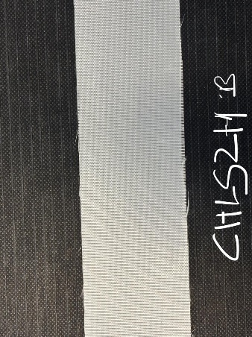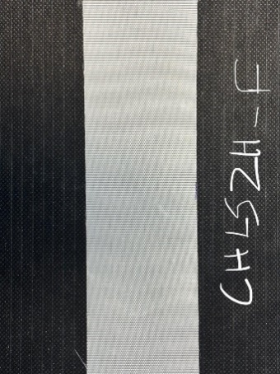
NAME- POLY FIBER GLASS TAPE  Type- CHPFG  Thickness Range – 0.14 to 0.16 mm | 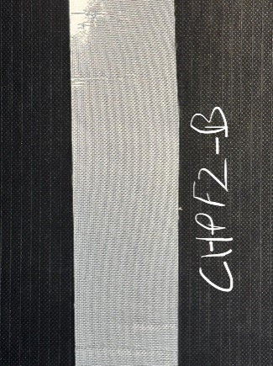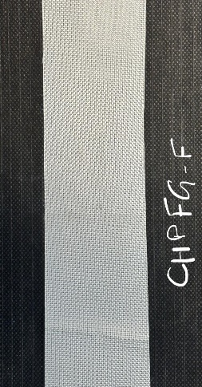 | NAME- FIBER GLASS TAPE  Type- CHFGT  Thickness Range-  0.10 to 0.60mm | 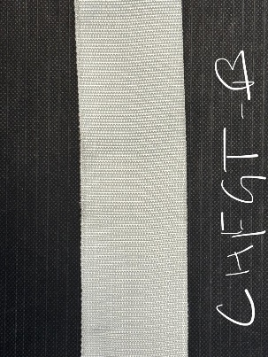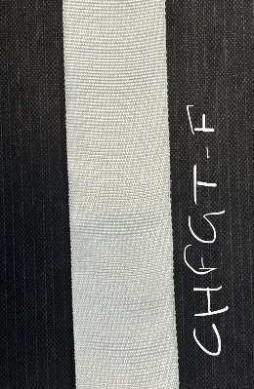
NAME- COTTON TAPE  Type- CHCT  Thickness – 0.14 mm | 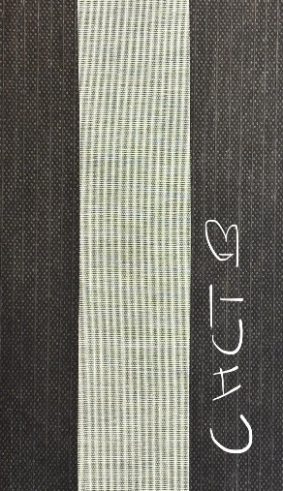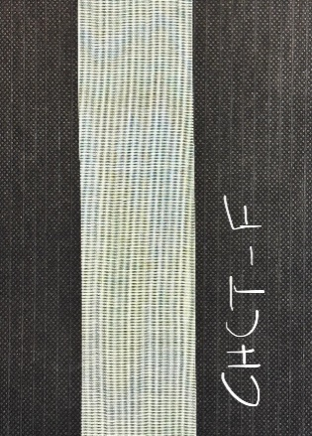 | NAME- BITTUMINIZED TAPE  Type- CHBCT  Thickness Range-  0.20 to 0.40mm | 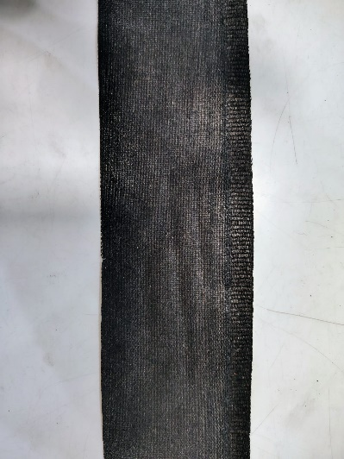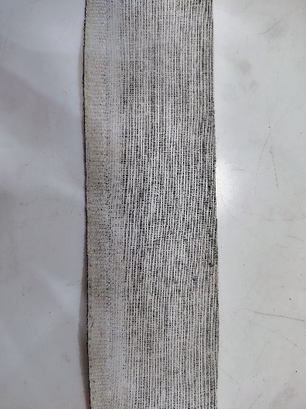
NAME- ALUMINIUM MYLAR TAPE  Type- CHALPET  Thickness Range – 0.025 to 0.10mm | 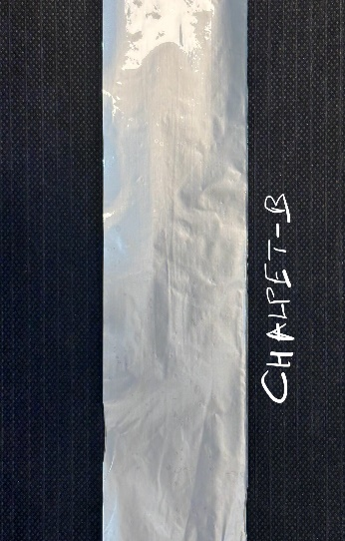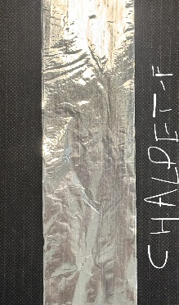 | NAME- POLYESTER TAPE  Type- CHPET  Thickness Range-  0.15 to 0.2mm | 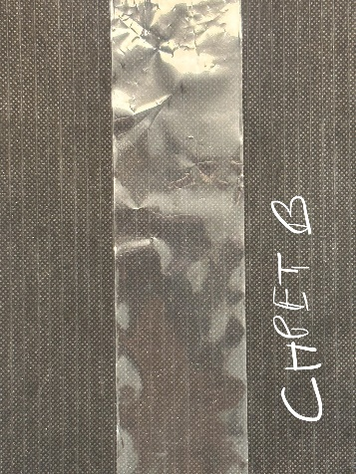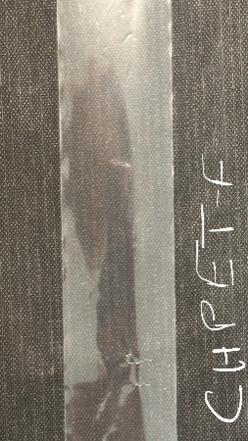
NAME- NON-WOVEN FLEECE TAPE  Type- CHNW  Thickness Range – 0.05 to 0.20mm | 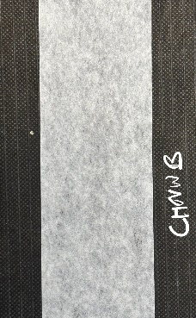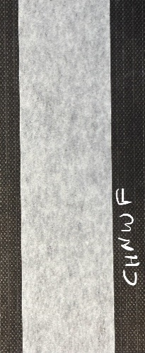 | NAME- FOAMED PP TAPE  Type- CHFPP  Thickness Range- 0.08 to 0.2mm | 